Civil war in [Rwanda]

UNSC Resolution: | 1329
Date of adoption: | 5-December-2000
Operative paragraph: | 5
Demand number: | 1329.0511

[Philippe Rieder]

Wording of demand
Cooperate fully with the International Tribunals and their organs in accordance with their obligations under resolutions 827 (1993) and 955 (1994) and the Statutes of the International Tribunals

List of addressees of the demand

Government of Rwanda

Short-term compliance

Description of the addressee(s)’ conduct

“Speaking on the International Criminal Tribunal for Rwanda [on the 4150th meeting at 2 June 2000], the Prosecutor reported that relations with the Government of Rwanda had improved after the reversal of a decision by the Appeals Chamber to release the accused in the Barayagwiza case, and that cooperation with the Government of Rwanda was now excellent. She reported on plans by the Government of Rwanda to introduce a traditional form of justice called
gachacha to alleviate an overcrowding of prisons.” (Items relating to the International Criminal Tribunals, in: UNSC Repertoire 14th Supplement (2000 – 2003): Chapter VIII, p. 2f)

“In an interview on 13 December 2000, Carla del Ponte (at that time Chief Prosecutor at the ICTR) stated that she had opened (in 1999) an investigation into alleged war crimes committed by the RPF during 1994 and had informed the Rwandan government at the time. On 9 December 2000, del Ponte held a private meeting with President Kagame at which he had agreed to co-operate fully with the investigation into three specific cases of alleged massacres [Integrated Regional Information Network (IRIN) for Central and Eastern Africa, 2000, xiii].“ (Nigel Eltringham, Accounting for Horror, Pluto Press London 2004, p. 107).

“99. The period under review saw an evolution in the relationship between the Office of the Prosecutor and the authorities of Rwanda. While regular contacts continued to be established with the Government in Kigali at a working level, particularly through the
Office of the Prosecutor General, Mr. Gérard Gahima the Prosecutor also met with President Kagame on several occasions. In addition she had numerous meetings with the Minister of Justice and with the Military Auditor. The basic feature of all these meetings was an increased openness on the part of the Prosecutor to inform the authorities of Rwanda of the nature of the work conducted by her Office and to explain the policy behind the activities of her investigators. As a result, a greater flow of information and a higher level of understanding, coordination of efforts and cooperation were achieved.” (Sixth annual report of the International Criminal Tribunal for the Prosecution of Persons Responsible for Genocide and Other Serious Violations of International Humanitarian Law Committed in the Territory of Rwanda and Rwandan
Citizens Responsible for Genocide and Other Such Violations Committed in the Territory of Neighbouring States between 1 January and 31 December 1994 for the period from 1 July 2000 to 30 June 2001, (A/56/351–S/2001/863), 14 September 2001, p. 16)

“100. The Prosecutor stressed her understanding of the need to make the work of the Tribunal relevant to the people of Rwanda and reiterated her desire to hold parts of trials in Kigali. She helped to facilitate the provision of international assistance for the refurbishment of the premises of the Supreme Court of Rwanda, with a view to that court being suitably equipped to accommodate the Tribunal’s hearings.” (Sixth annual report of the International Criminal Tribunal for the Prosecution of Persons Responsible for Genocide and Other Serious Violations of International Humanitarian Law Committed in the Territory of Rwanda and Rwandan
Citizens Responsible for Genocide and Other Such Violations Committed in the Territory of Neighbouring States between 1 January and 31 December 1994 for the period from 1 July 2000 to 30 June 2001, (A/56/351–S/2001/863), 14 September 2001, p. 16)

“103. The Prosecutor is of the view that the Investigations Division in her Office is empowered tointerrogate suspects, interview witnesses and victims, take witness statements and gather evidence against presumed perpetrators of crimes, falling under the jurisdiction of the Tribunal. For reasons of security and confidentiality, the present report cannot give details of ongoing investigations or of the suspects who are the objects of the Prosecutor’s attention. In general terms, however, current investigations are concerned, inter alia, with central and local government figures, members of the armed forces, militias and civil defence, prominent businessmen and intellectuals, members of the clergy and certain media figures. The Tribunal’s mandate also allows the Prosecutor to investigate allegations of crimes committed by
members of the Rwandan Patriotic Front (RPF) in the aftermath of the genocide in 1994.” (Sixth annual report of the International Criminal Tribunal for the Prosecution of Persons Responsible for Genocide and Other Serious Violations of International Humanitarian Law Committed in the Territory of Rwanda and Rwandan
Citizens Responsible for Genocide and Other Such Violations Committed in the Territory of Neighbouring States between 1 January and 31 December 1994 for the period from 1 July 2000 to 30 June 2001, (A/56/351–S/2001/863), 14 September 2001, p. 16)

“145. The focal point for the Outreach Programme is the Tribunal’s information centre Umusanzu mu Bwiyunge in Kigali, which was inaugurated on 25 September 2000. It is located in a building donated by the Government of Rwanda and situated in the centre of Kigali. Heavy use is made of all the facilities in the centre by a wide spectrum of Rwandan society. In the first three months of 2001 the centre received over 6,000 visitors.” (Sixth annual report of the International Criminal Tribunal for the Prosecution of Persons Responsible for Genocide and Other Serious Violations of International Humanitarian Law Committed in the Territory of Rwanda and Rwandan
Citizens Responsible for Genocide and Other Such Violations Committed in the Territory of Neighbouring States between 1 January and 31 December 1994 for the period from 1 July 2000 to 30 June 2001, (A/56/351–S/2001/863), 14 September 2001, p. 16)

Assessment

Short-term compliance
No or marginal compliance (1) | Medium low compliance (2) | Medium high compliance (3) | X Full or almost full compliance (4)

Considerations underlying the assessment
The relations of Rwanda and the ICTR improved greatly with the convictions of key figures of the genocide such as Jean Kambanda and Jean-Paul Akayesu.

Medium-term compliance

Description of the addressee(s)’ conduct

“The Prosecutor, in connection with the “exit strategy” of the Tribunals, outlined her future prosecution policy in order to give the Council an understanding of the work before the Tribunals before they could complete their respective mandates. She stated that she intended to focus on the leaders in both Rwanda and the former Yugoslavia, but stressed that local leaders had also played an important role as organizers and motivators of major crimes. She held that the figures for remaining investigations she had given – 36 investigations for the International Criminal Tribunal for the Former Yugoslavia, and 136 for the International Criminal Tribunal for Rwanda – were only a fraction of the potential number of crimes or suspects. Speaking on the International Criminal Tribunal for Rwanda, she estimated that the end of 2008 might be a realistic date for the end strategy for the trials in that Tribunal.” (Items relating to the International Criminal Tribunals, in: UNSC Repertoire 14th Supplement (2000 – 2003): Chapter VIII, p. 15)

“The representative of Rwanda emphasized that it was essential to bring to trial those suspected of genocide and held that it was not the time to reduce the capacities of the International Criminal Tribunal for Rwanda, but to build them up. As to areas of improvements for the Tribunal, he suggested that the programme of information of the
Tribunal could be improved, assistance to witnesses should be increased and access to
AIDS medication should be provided for rape victims at the time of the genocide. In addition, he encouraged the recruitment of Rwandans for the Tribunal, but appealed for greater care in the choice of persons recruited to prevent the abusive sharing of fees among the defence counsels and detainees or the hiring of individuals suspected of genocide. He urged for compensation of victims and for a fuller participation of victims in the activities of the Tribunal. He also argued for the seat of the Tribunal to be relocated to Rwanda.” (Items relating to the International Criminal Tribunals, in: UNSC Repertoire 14th Supplement (2000 – 2003): Chapter VIII, p. 16)

“In April 2001, Kagame reportedly agreed to hand over to the tribunal any army officers
suspected of committing crimes in 1994 [Integrated Regional Information Network (IRIN) for Central and Eastern Africa, 2001, ii]. In April 2002, however, del Ponte’s spokesperson announced that she was ‘not satisfied’ with the level of co-operation received from the Rwandan authorities and was dissatisfied with the access to archives, documents and witnesses in Rwanda, although she had hoped to issue an indictment by the end of the year [Integrated Regional Information Network (IRIN) for Central and Eastern Africa, 2002, ii].” (Nigel Eltringham, Accounting for Horror, Pluto Press London 2004, p. 107).

“Concerned by the allegations of mistreatment of witnesses in general and in particular of those called from Rwanda to testify in Arusha, the Registrar of the Tribunal, in a letter dated 4 March 2002, had proposed to the Government of Rwanda, out of concern for transparency and fairness, to establish a joint commission to investigate the allegations of mistreatment of witnesses coming from Rwanda, echoed by certain Rwandan authorities and non-governmental organizations in recent public statements.
In response to the Registrar’s proposal, the Government of Rwanda, while accepting in principle the establishment of the joint commission, stated, for its part, in a letter dated 13 March 2002, that it would wish to expand the commission’s terms of reference to include matters regarding, inter alia, the recruitment and employment of staff members and auxiliary staff of Rwandan origin in service with the Tribunal either in Arusha or in Kigali, and the arrangements planned and administered by the Registry of the Tribunal for the care and protection of witnesses.” (STATEMENT BY THE REGISTRAR ON THE RESPONSE OF THE GOVERNMENT OF RWANDA TO THE PROPOSAL TO ESTABLISH A JOINT COMMISSION TO INVESTIGATE THE ALLEGATIONS OF MISTREATMENT OF WITNESSES COMING FROM RWANDA, (ICTR/INFO-9-3-09.EN), 28 March 2002)

“On July 2002, I received a copy of the report from the Prosecutor of the International Tribunal for Rwanda, which was also brought to the attention of the Security Council. In that report, the Prosecutor complains of lack of cooperation from the Rwandan authorities and, in particular, describes how the lack of availability of witnesses from Rwanda is likely to hamper the judicial work of the International tribunal and hinder the Prosecutor’s investigations. (...)
In particular, the Judges of the International Tribunal are concerned because three cases (the Kajelijeli, Nyitegaka and Butare cases) have already been postponed on numerous occasions this year owing to the unavailability of witnesses from Rwanda. Two Trial Chambers have issued decisions drawing attention to the Rwandan Government’s failure to issue travel documents in a timely manner so that witnesses could appear before the International Tribunal. Both decisions have been brought to the notice of the Rwandan Government. Copies of those decisions are attached to this letter (see annexes).
In the light of past difficulties, it is uncertain that the trials scheduled to resume in the coming sessions will be able to do so without the intervention of the Security Council.” (Letter dated 26. July 2002 from the President of ICTR addressed to the President of the Security Council, (S/2002/847), 29 July 2002, p. 1)

“(…) During the period under review, the Tribunal experienced problems over the flow of witnesses from Rwanda. The call for non-cooperation with the Tribunal by some Rwandan survivors’ groups resulted in a number of witnesses refusing to testify. In two
cases where this problem arose, the Trial Chambers ordered that the witnesses be removed from the witness list and the trial proceeded without their testimony.
87. Relations between the Tribunal and the Government of Rwanda have remained positive. However, in June 2002, the Witness and Victims Support Section-Prosecution encountered serious difficulties over the travel of witnesses from Rwanda after the Rwandan Authorities apparently changed the requirements for the issue of travel documents, these requirements not having been made known to the Tribunal in advance. Witnesses were now required to personally obtain three clearance certificates from various local offices. The latter were often unknown or inaccessible and witnesses could not obtain the documents. They also faced risks of exposing their identities, which are protected by witness protection orders issued by Trial Chambers. This prevented the
Tribunal from bringing witnesses out of Rwanda and as a consequence two trials ground to a standstill, resulting in valuable court days being lost and wasted costs incurred. The Registrar took immediate steps to seek restoration of cooperation with the Rwandan authorities. He served the two Trial Chamber decisions addressed to the Government and held discussions with the Head of State and other authorities.” (Report of the International Criminal Tribunal for the Prosecution of Persons Responsible for Genocide and Other Serious Violations of International Humanitarian Law Committed in the Territory of Rwanda and Rwandan Citizens Responsible for Genocide and Other Such Violations Committed in theTerritory of Neighbouring States between 1 January and 31 December 1994, (A/57/163–S/2002/733), 2 July 2002, p. 13f )

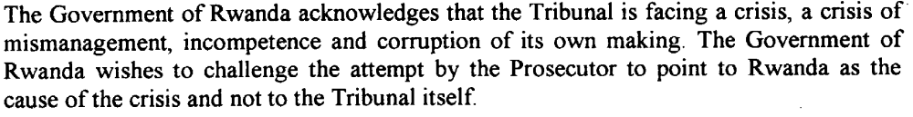
(Annex of Letter dated 26 July 2002 from the permanent Representative of Rwanda to the UN addressed to the President of the Security Council, (S/2002/842), 26 July 2002, p. 2)

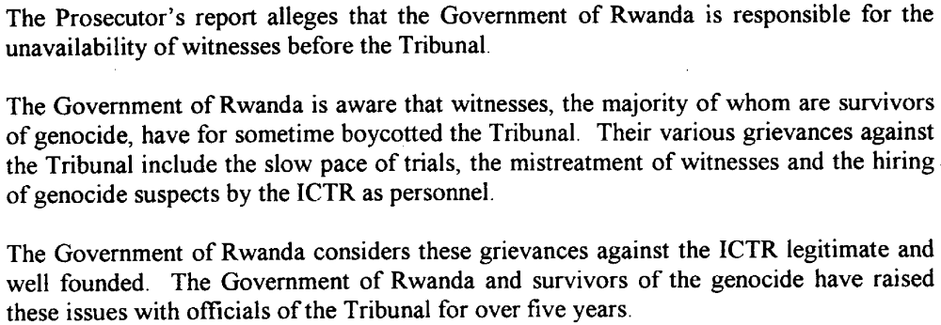
(Annex of Letter dated 26 July 2002 from the permanent Representative of Rwanda to the UN addressed to the President of the Security Council, (S/2002/842), 26 July 2002, p. 2)
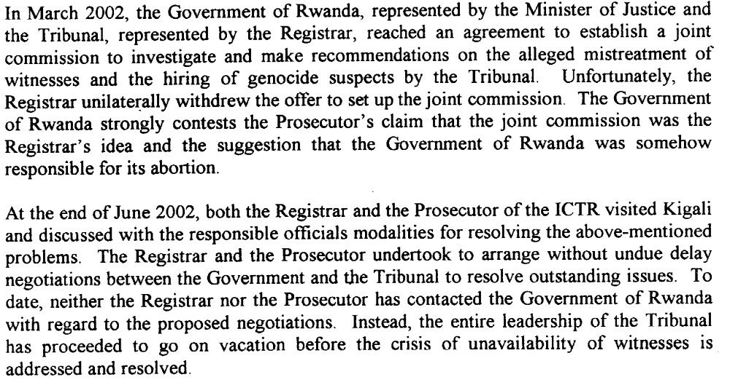
(Annex of Letter dated 26 July 2002 from the permanent Representative of Rwanda to the UN addressed to the President of the Security Council, (S/2002/842), 26 July 2002, p. 2)
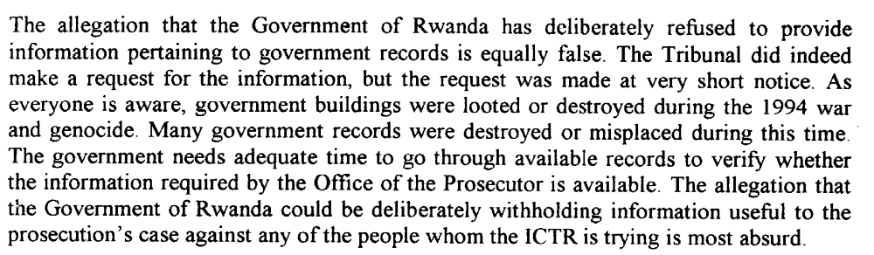
(Annex of Letter dated 26 July 2002 from the permanent Representative of Rwanda to the UN addressed to the President of the Security Council, (S/2002/842), 26 July 2002, p. 4)

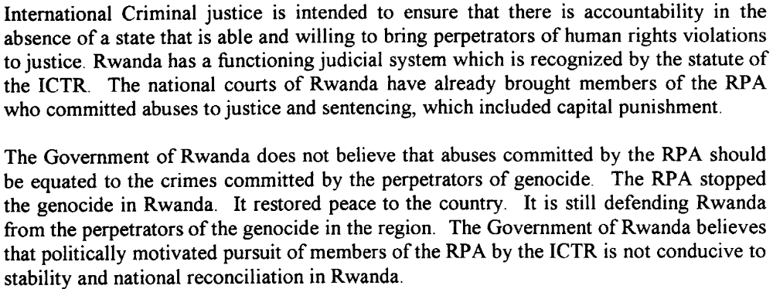

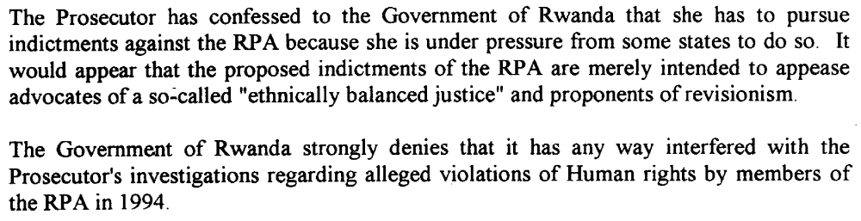
(Annex of Letter dated 26 July 2002 from the permanent Representative of Rwanda to the UN addressed to the President of the Security Council, (S/2002/842), 26 July 2002, p. 5)

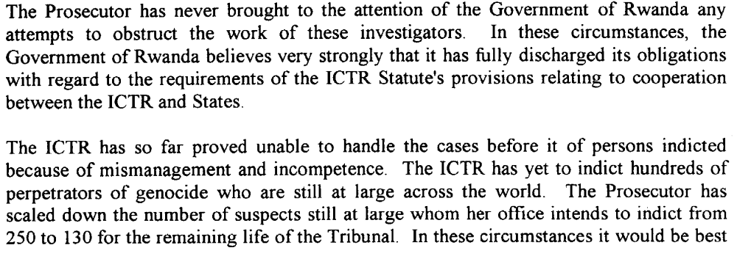
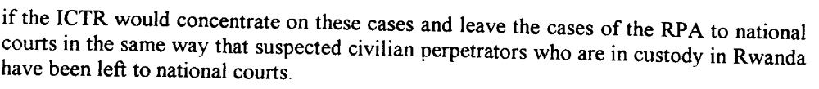
(Annex of Letter dated 26 July 2002 from the permanent Representative of Rwanda to the UN addressed to the President of the Security Council, (S/2002/842), 26 July 2002, p. 5)

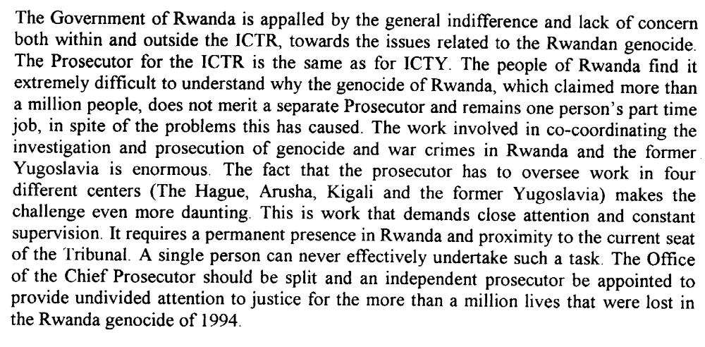(Annex of Letter dated 26 July 2002 from the permanent Representative of Rwanda to the UN addressed to the President of the Security Council, (S/2002/842), 26 July 2002, p. 5)

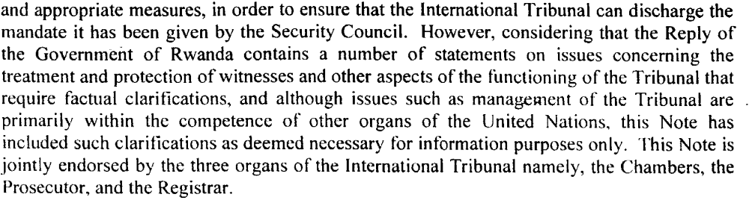
(Letter dated 8 August 2002 from the President of the ICTR addressed to the President of the Security Council, (S/2002/923), 13 August 2002, p. 2f)

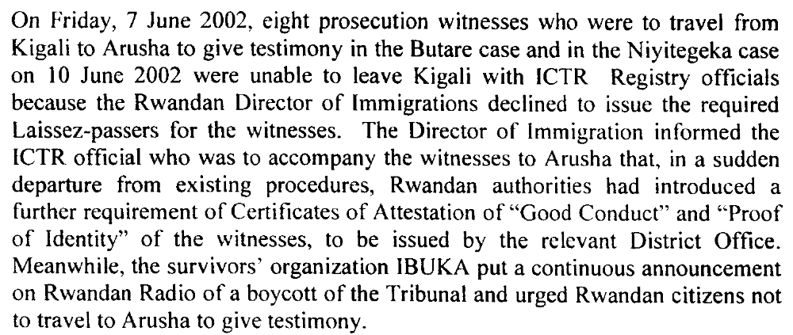
(Letter dated 8 August 2002 from the President of the ICTR addressed to the President of the Security Council, (S/2002/923), 13 August 2002, p. 3)

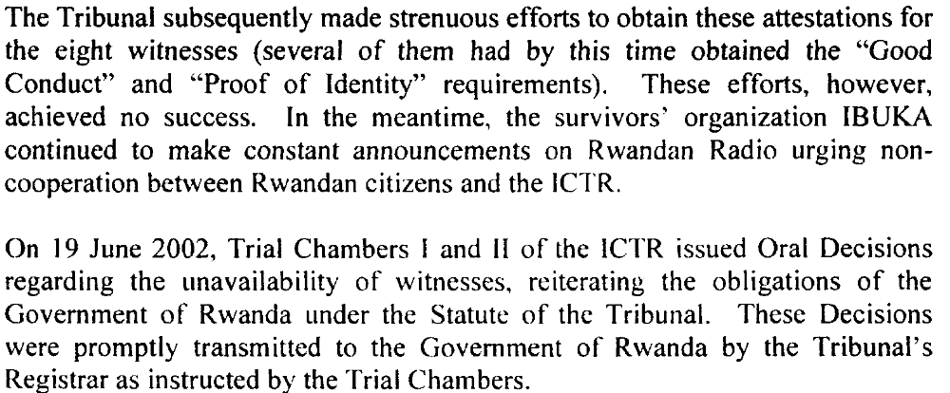

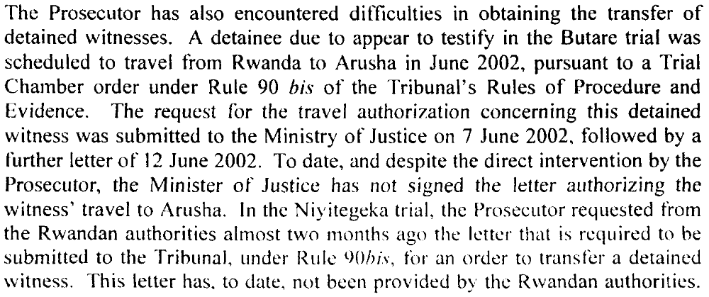
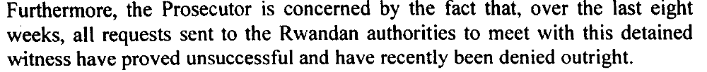
(Letter dated 8 August 2002 from the President of the ICTR addressed to the President of the Security Council, (S/2002/923), 13 August 2002, p. 4f)
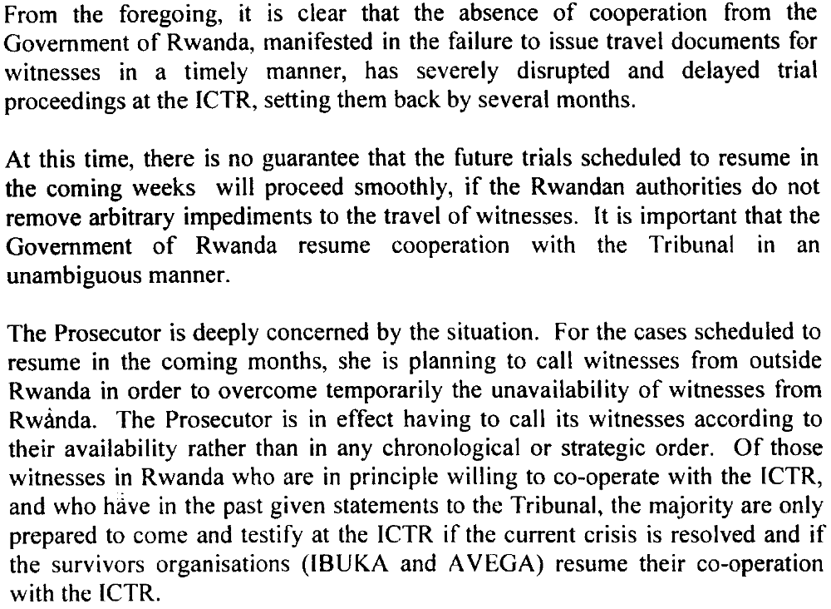
(Letter dated 8 August 2002 from the President of the ICTR addressed to the President of the Security Council, (S/2002/923), 13 August 2002, p. 5)

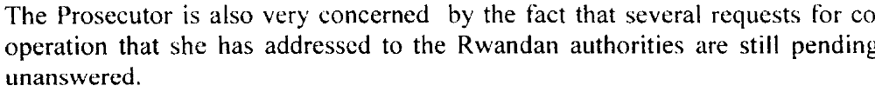
(Letter dated 8 August 2002 from the President of the ICTR addressed to the President of the Security Council, (S/2002/923), 13 August 2002, p. 5)
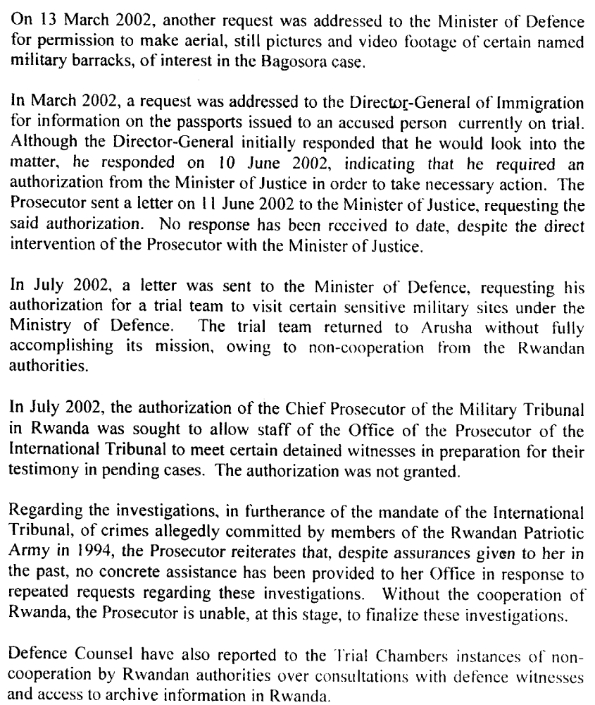
(Letter dated 8 August 2002 from the President of the ICTR addressed to the President of the Security Council, (S/2002/923), 13 August 2002, p. 5)
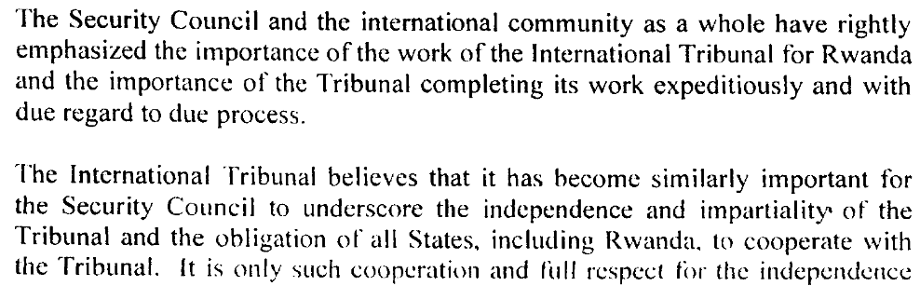
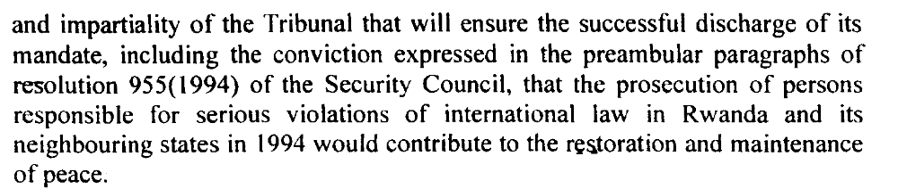
(Letter dated 8 August 2002 from the President of the ICTR addressed to the President of the Security Council, (S/2002/923), 13 August 2002, p. 10f)

“87. Relations between the Tribunal and the Government of Rwanda have remained positive. However, in June 2002, the Witness and Victims Support Section-Prosecution encountered serious difficulties over the travel of witnesses from Rwanda after the Rwandan Authorities apparently changed the requirements for the issue of travel documents, these requirements not having been made known to the Tribunal in advance. Witnesses were now required to personally obtain three clearance certificates from various local offices. The latter were often unknown or inaccessible and witnesses could not obtain the documents. They also faced risks of exposing their identities, which are protected by witness protection orders issued by Trial Chambers. This prevented the Tribunal from bringing witnesses out of Rwanda and as a consequence two trials ground to a standstill, resulting in valuable court days being lost and wasted costs incurred. The Registrar took immediate steps to seek restoration of cooperation with the Rwandan authorities. He served the two Trial Chamber decisions addressed to the Government and held discussions with the Head of State and other authorities.” (Report of the International Criminal Tribunal for the Prosecution of Persons Responsible for Genocide and Other Serious Violations of International Humanitarian Law Committed in the Territory of Rwanda and Rwandan Citizens Responsible for Genocide and Other Such Violations Committed in the Territory of Neighbouring States between 1 January and 31 December 1994, (A/57/163–S/2002/733), 2 July 2002, p. 14)

“While States had assisted the Tribunal in arranging contact with and facilitating the travel of witnesses, the Tribunal had this year experienced difficulties over the flow of witnesses from Rwanda. The non-appearance of those witnesses had disrupted the careful planning of the judicial calendar and was a severe setback to the judicial work. Indeed, the Rwandan Government appeared to have suspended cooperation with the Tribunal. She had reported that lack of cooperation to the Security Council, and she urged the Council to prevail on Rwanda to restore the cooperation it had accorded to the Tribunal for the past seven-and-a-half years.” (UNGA Press Release, (GA/10088), 28 October 2002)

“The Security Council (…) Reaffirms its support for the International Criminal Tribunal for Rwanda and the International Criminal Tribunal for the Former Yugoslavia ; recalls the mandatory obligations of all States, including the Governments of Rwanda and Yugoslavia, under resolutions 955 (1994) and 827 (1993) and the Statutes of the Tribunals, to cooperate fully with the Tribunals and their organs; stresses the importance it attaches to full cooperation by all States, particularly those directly concerned with the Tribunals; also stresses importance of constructive dialogue between the Tribunals and the Governments concerned to resolve any outstanding issues affecting the work of the Tribunals but insists that such dialogue or lack of dialogue must not be used by the States as excuse for failure to discharge their obligations to cooperate fully with the Tribunals.” (Statement by the President of the Security Council,(S/PRST/2002/39), 18 December 2002)

Assessment

Medium-term compliance
No or marginal compliance (1) | X Medium low compliance (2) | Medium high compliance (3) | Full or almost full compliance (4)

Considerations underlying the assessment

Trying the masterminds of the genocide was in the interest of the government of National Unity. Rwanda thus supported the establishment of the ICTR. During 2002 however, the relationship soured and cooperation all but ceased. In the view of the RPF-dominated government, the UN had not done anything to stop the genocide in 1994 and now interfered with national justice and stability. Particularly pressing charges against RPA-cadres was seen as counter-productive, as the Government stressed the much greater responsibility of the perpetrators of the genocide. Furthermore Rwanda was irritated by the slow pace of the trials and the financing of legal defense teams with relations to the Hutu extremists by the international community.

Depth of Demand

Assessment

Level of depth of demand
X Low depth of demand (1) | Medium depth of demand (2) | High depth of demand (3)

Considerations underlying the assessment

Level of confidence about coding decisions

Level of confidence about coding decision
Extremely high | High | X Moderate

Comments to IPI (if any)

